**10.1 Study Guide and Intervention**

***Geometric Mean***

**Geometric Mean** The **geometric mean** between two numbers is the positive square root of their product.   
For two positive numbers *a* and *b*, the geometric mean of *a* and *b* is the positive number *x* in the proportion $\frac{a}{x}$ = $\frac{x}{b}$.   
Cross multiplying gives $x^{2}$ = *ab*, so *x* = $\sqrt{ab}$*.*

**Example : Find the geometric mean between each pair of numbers.**

**a. 12 and 3**

*x* = $\sqrt{ab}$ Definition of geometric mean

= $\sqrt{12⋅3}$*a* = 12 and *b* = 3

= $\sqrt{(2⋅2⋅3)⋅3}$ Factor.

= 6 Simplify.

The geometric mean between 12 and 3 is 6.

**b. 8 and 4**

*x* = $\sqrt{ab}$ Definition of geometric mean

= $\sqrt{8⋅4}$*a* = 8 and *b* = 4

= $\sqrt{(2⋅4)⋅4}$ Factor.

= $\sqrt{16⋅2}$ Associative Property

= 4 $\sqrt{2}$ Simplify.

The geometric mean between 8 and 4 is 4 $\sqrt{2}$ or about 5.7.

**Exercises**

**Find the geometric mean between each pair of numbers.**

**1.** 4 and 4 **2.** 4 and 6

**3.** 6 and 9 **4. $\frac{1}{2}$**  and 2

**5.** 12 and 20 **6.** 4 and 25

**7.** 16 and 30 **8.** 10 and 100

**9. $\frac{1}{2}$**  and $\frac{1}{4}$**10.** 17 and 3

**11.** 4 and 16 **12.** 3 and 24

**10.1 Study Guide and Intervention** *(continued)*

***Geometric Mean***

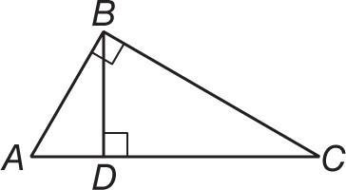

**Geometric Means in Right Triangles** In the diagram, △*ABC* ∼ △*ADB* ∼ △*BDC*.   
An altitude to the hypotenuse of a right triangle forms two right triangles. The two triangles are similar and each is similar to the original triangle.

**Example 1: Use right △ *ABC* with $\overline{BD}$ ⊥ $\overline{AC}$. Describe two geometric means.**

**a.** △*ADB* ∼ △*BDC* so $\frac{AD}{BD}$ = $\frac{BD}{CD}$.

In △*ABC*, the altitude is the geometric mean between the two segments of the hypotenuse.

**b.** △ABC ∼ △*ADB* and △*ABC* ∼ △*BDC*,

so $\frac{AC}{ AB}$ = $\frac{AB }{AD}$ and $\frac{AC }{BC}$ = $\frac{BC}{DC}$.

In △ *ABC*, each leg is the geometric mean between the hypotenuse and the segment of the hypotenuse adjacent to that leg.

**Example 2: Find *x*, *y*, and *z*.**

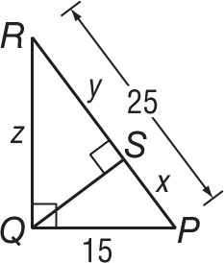 15 = $\sqrt{RP⋅SP}$ Geometric Mean (Leg) Theorem

15 = $\sqrt{25x}$ *RP* = 25 and *SP* = *x*

225 = 25*x* Square each side.

9 = *x* Divide each side by 25.

Then

*y* = *RP* – *SP*

= 25 – 9

= 16

*z* = $\sqrt{RS⋅RP}$ Geometric Mean (Leg) Theorem

= $\sqrt{16⋅25}$*RS* = 16 and *RP* = 25

= $\sqrt{400}$ Multiply.

= 20 Simplify.

**Exercises**

**Find *x*, *y*, and *z* to the nearest tenth.**

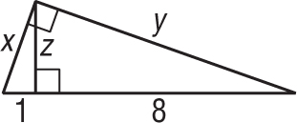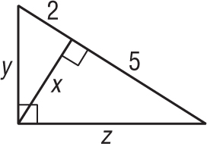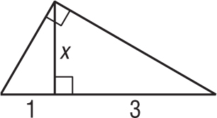**1. 2. 3.**

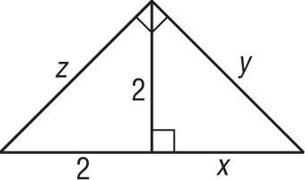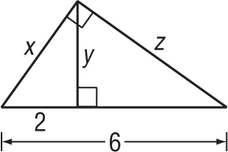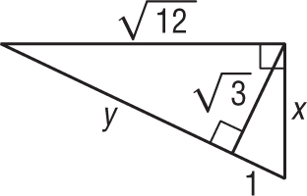 **4. 5. 6.**